Session 9
- Generate 100 random numbers in Python that follow a normal distribution with mean 50 and standard deviation 10 using numpy, then plot the bell curve using matplotlib.

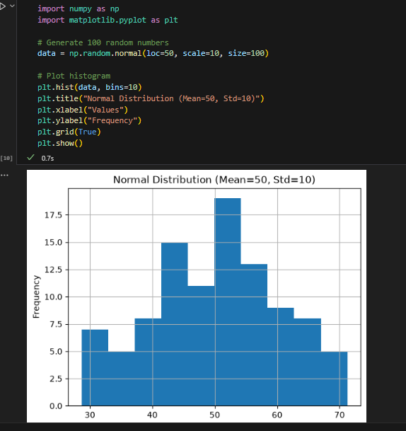

- Given an array of 20 daily step counts from your fitness tracker app, calculate the mean, median, and mode, and check if they are approximately equal as expected in a normal distribution.<br><br><em><strong>Hint:</strong> Use numpy.mean(), numpy.median(), and scipy.stats.mode().</em>
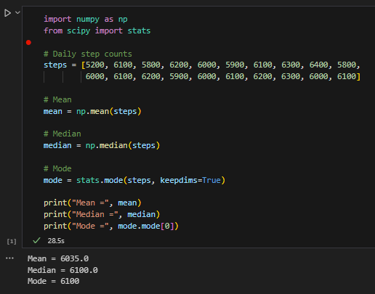
- Simulate the scores of 200 players in an online game (e.g., PUBG, Free Fire) using a normal distribution with mean 70 and standard deviation 15, then count how many players scored within one standard deviation (between 55 and 85) of the mean.<br><br><em><strong>Hint:</strong> Use the 68-95-99 rule to check your answer.</em>
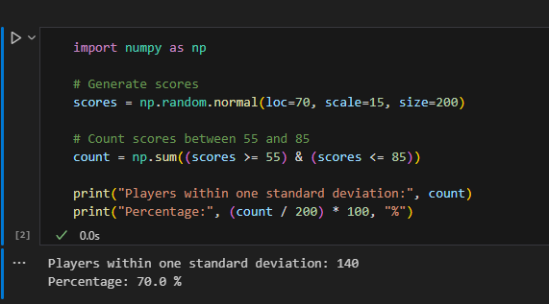

- Pick any real-world scenario (like delivery times for Zomato orders or playlist song durations on Spotify) and explain in 3-4 lines why the normal distribution might be a good fit for modeling this data.

Answer
Example: Zomato Delivery Times
Delivery times for Zomato orders often follow a normal distribution because most deliveries are completed around the average time. A few deliveries are much faster or much slower due to traffic or weather conditions. This creates a bell-shaped pattern where most values are near the mean, making the normal distribution a good model.

